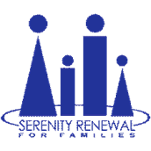

Serenity Renewal for Families is pleased to announce the appointment of Marian Meade to the role of Director of Counselling at Serenity Renewal for Families. Marian comes to Serenity with over 28 years of experience as a RN Psychotherapist Educator and Coach. In addition to maintaining a private practice in psychotherapy, Marian has worked for Alberta Health Services as a psychotherapist in their Dialectical Behaviour Therapy (DBT) program as well as a psychotherapist in the day program at Rockyview Hospital in Calgary. Active in the community, Marian currently serves as a Vice President with Mental Health Professionals Ottawa, a networking and educational group for therapists, counsellors, psychologists, and certified coaches. Building upon the work Serenity has done for the past 35 years, Marian is excited to support the mission and the expansion of our services.

